**Computer Network Lab Exam Exercise Report**

**Objective:**

Set up and configure a network topology using RIP and OSPF routing protocols in Cisco Packet

Tracer. Customize the network by assigning each computer a name and an IP address using the

last three digits of your roll number.

**Procedure:**

**1. Network Topology Design:**

○ Create a topology that includes:

■ 10-12 computers distributed across two LANs.

■ Use two or more switches.

■ At least two routers connected via a WAN link.

○ Each computer must be assigned a name with the format: PC_RollNumber (e.g.,

PC_123).

**2. IP Address Configuration:**

○ Assign IP addresses to the computers in each LAN.

○ The last three digits of each student's roll number must be used for the last octet

of the computer’s IP address (e.g., 192.168.1.RollNumber).

○ Use a different subnet for each LAN (e.g., 192.168.1.0/24 for LAN 1 and

192.168.2.0/24 for LAN 2).

**3. Routing Protocols Configuration:**

○ Configure one router with RIP v1.

○ Configure the other router with OSPF.

○ Ensure communication between LANs using these protocols.

**4. Packet Tracer Configuration Steps:**

○ Add devices and create connections between them.

○ Configure IP addresses on the computers, switches, and routers.

○ Set up static routes or enable RIP/OSPF on the routers.

○ Ensure correct routing between the two LANs and that data can be transmitted

between networks.

**5. Simulation:**

○ Use Cisco Packet Tracer’s simulation mode to test message transmission.

○ Ensure a message can be successfully transmitted from one network to another.

Network

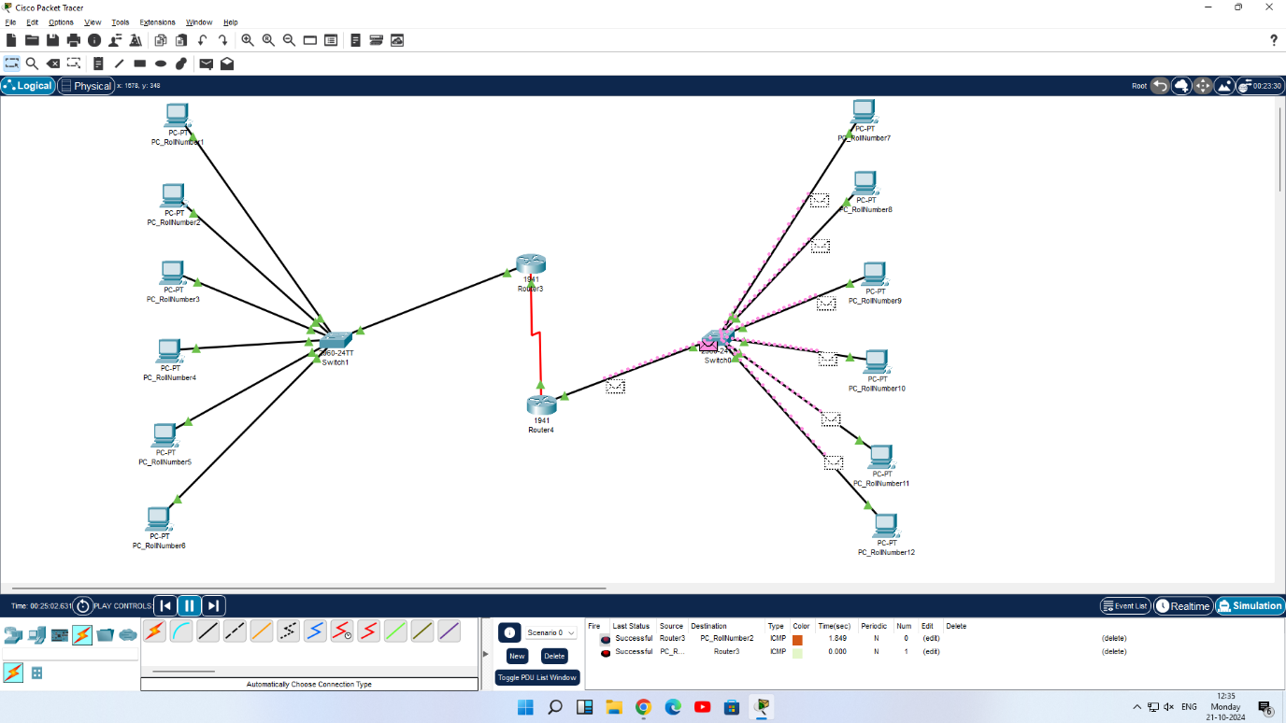

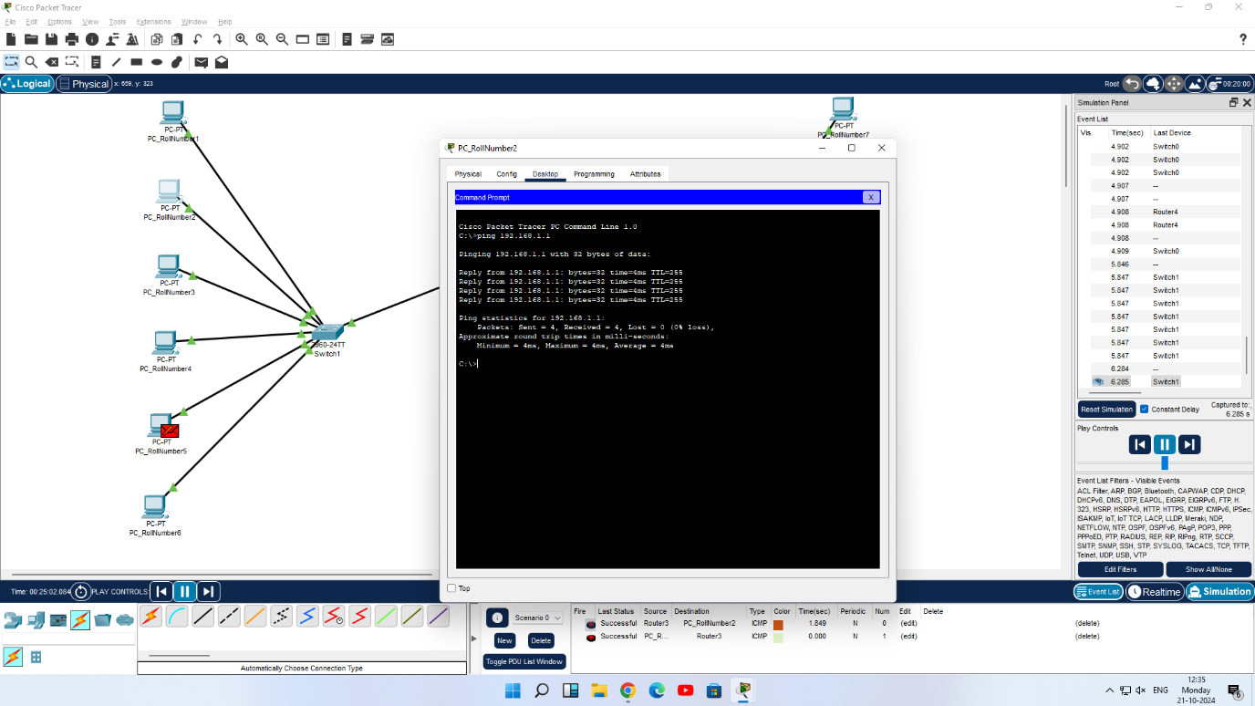

**Results:**

Configured a network topology using RIP and OSPF routing protocols in Cisco Packet

Tracer. Customized the network by assigning each computer a name and an IP address using the

last three digits of Roll number and achieved Results.